Deployment Steps For Infrastructure
- Run Deploy Base Infra
- Get your ip details in for the subnets
- Run 02_Sandbox_DeployNetwork.ps1

- Assign this role to the service principal running the deployment

- Run 03_Sandbox_DeployInfra.ps1

- Populate these secrets

- And this certificate
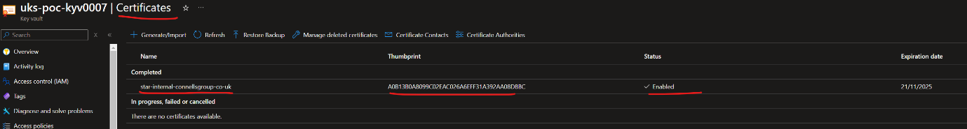

you need the following access to do the above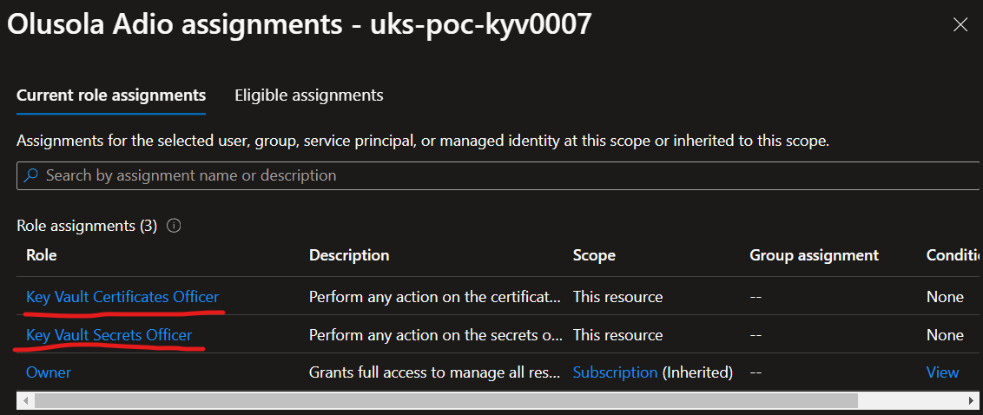

- Run 04_Sandbox_DeployAPIM_Basic.ps1

- Run 04_Sandbox_DeployAPIM_Full.ps1

- Set the private IP of the App gateway.
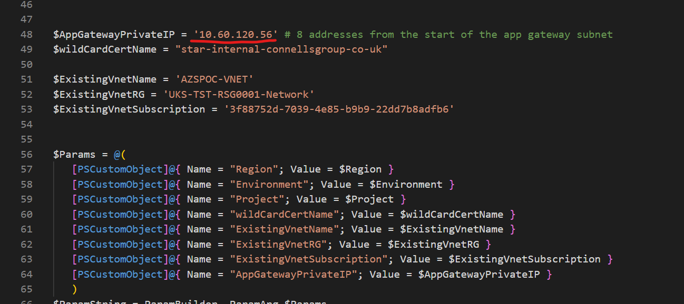

- Run 05_Sandbox_DeployAGW.ps1

- Get Chris Ring to do DNS entries for us


